**WynbergTest Drives**

**Test Document – prepared for GreatGuide Android Release 3 testing**

**Tour 1 – TestDrive1**

Areas in Tour 1 test drive sequence

* Office - While in priority 2
* Polly (twice) –Always, Priority 1, Trigger count 2
* DayOfWeek - Monday
* TimeOfDay - 9-11am
* Seq1 – Seq 2 is slave
* Seq2 – Seq 1 is master, Seq 3 is slave
* Seq3 – Seq 2 is master
* South - 160 +- 45deg
* Delay 20s
* SeqDirec1 –Seq master - Direction 270
* SeqDirec2 – Seq child - Direction 270
* Exit
* AlwaysPriority1
* Entry
* Filler - Priority 3 backround

Tour 1 - Drive 1 Route Details

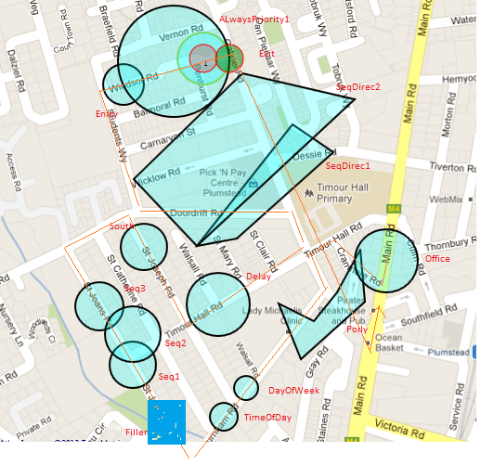

Tour 1 - Drive 1 Test Sheet

Directions

* Start at office – drive South
* Turn right into Cranmere road
* Left into Timour Hall Road
* Left into Gabriel Road
* Right into Burnham
* 3rd right into St Joans
* Right into Doordrift
* 2nd right into St Josephs
* Left into Timour Hall
* 2nd Left into Gabriel
* First Left into Doordrift
* Right into Students Way
* 4th Right Windsor
* Right Gabriel
* Left in Main road
* Stop at office

Date and Time of Test : ………………………..

|  |  |  |  |  |  |
| --- | --- | --- | --- | --- | --- |
| Step | Where | Result Expected | Result | Rule 1 | Rule 2 |
| 1 | Start | Office.mp3 plays |  | Always |  |
| 2 | Cranmere road | Polly.mp3 plays |  | Entry | Priority |
| 3 | Burnham Road + 20m | Polly.mp3 plays |  | Entry | Trigger 2 |
| 4 | Burnham road + 50m | DayOfWeek.mp3 |  | Entry | Timed Area |
| 5 | Burnham Road + 100m | TimeOfDay.mp3 |  | Entry | Timed Area |
| 6 | St Joans | Filler1.mp3 plays |  | While in | Priority 3 |
| 7 | St Joans Road + 40m | Seq1.mp3 plays |  | Sequence |  |
| 8 | St Joans Road + 80m | Seq2.mp3 plays |  | Sequence |  |
| 9 | St Joans Road + 120m | Seq3.mp3 plays |  | Sequence |  |
| 10 | St Josephs road + 20m | South.mp3 plays |  | Direction |  |
| 11 | Doordrift Road + 20m | SeqDirec1.mp3 plays |  | Direction | Sequence |
| 12 | Doordrift road + 40m | SeqDirec2.mp3 plays |  | Direction | Sequence |
| 13 | Start Windsor | Entry.mp3 plays |  | Entry |  |
| 14 | Middle Windsor | AlwaysPriority1.mp3 interrupts Entry.mp3 |  | ALways | Prority 1 |
| 15 | End Windsor | Exit.mp3 plays |  | Exit | Prioity 1 finished |
| 16 | Gabriel start | nothing |  | Direction | Sequence |
| 17 | Gabriel end | Nothing (no Polly) |  | Trigger count |  |
| 18 | Main | Office.mp3 |  | Entry |  |

Tour 1 - Drive 2 Route Details (not all rules should trigger)

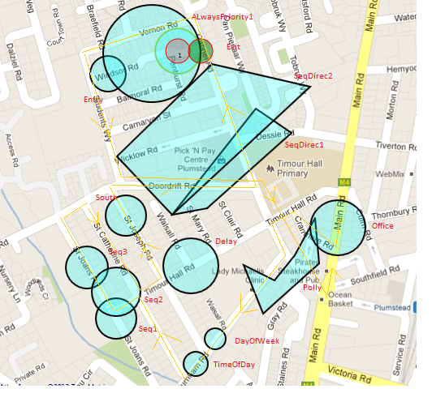

Tour 1 - Drive 2 Test Sheet

Directions

* Start at office – drive South
* Turn right into Cranmere road
* Left into Timour Hall Road
* Left into Gabriel Road
* Right into Burnham
* 2nd right into St Catherine
* Left into Timour Hall
* Right into St Joans
* Right into Doordrift
* Right into St Catherines
* Left into Timour hall
* Left into St Josephs
* Right into Doordrift
* Left into Gabriel
* Left into Vernon
* Left Into Students way
* Left into Doordrift
* Right into Gabriel
* Left into Maik
* Route ends at Office
* Date and Time of Test : ………………………..

|  |  |  |  |  |  |
| --- | --- | --- | --- | --- | --- |
| Step | Where | Result Expected | Result | Rule 1 | Rule 2 |
| 1 | Start | Office.mp3 plays |  | Always |  |
| 2 | Cranmere road | Polly.mp3 plays |  | Entry | Priority |
| 3 | Burnham Road + 20m | Polly.mp3 plays |  | Entry | Trigger 2wice |
| 4 | Burnham road + 50m | DayOfWeek.mp3 |  | Entry | Timed Area |
| 5 | Burnham Road + 100m | TimeOfDay.mp3 |  | Entry | Timed Area |
| 6 | Corner Catherine + Timour Hall | None |  | Sequence |  |
| 7 | Timour + 20m | Seq1.mp3 plays |  | Sequence |  |
| 8 | Corner Timour and St Joans | Seq2.mp3 plays |  | Sequence |  |
| 9 | St Joans road + 20m | Seq3.mp3 plays |  | Sequence |  |
| 10 | Catherines road | nothing |  | Sequence |  |
| 11 | St Josephs | Nothing |  | Direction |  |
| 12 | Doordrift | Nothing |  | Sequence | Direction |
| 13 | Gabriel | Nothing |  | Sequence | Direction |
| 14 | Windsor entry | AlwaysPriority1 |  | ALways | Priority |
| 15 | Windsor end | Nothing |  | Superceded |  |
| 16 | Doordrift | Nothing |  | Sequence | Direction |
| 17 | Gabriel | Nothing |  | Trigger count |  |
| 18 | Main road | Office.mp3 |  | Always |  |
| 19 |  |  |  |  |  |
| 20 |  |  |  |  |  |
| 21 |  |  |  |  |  |

**Tour 2- TestDrive1**

Areas in Tour 2 test drive sequence

* ImagePromptT2
* TourImage2
* VideoPromptT2
* TourVideo2
* FillerT2
* EntryT2
* ExitT2

Tour 2 - Drive 1 Route Details

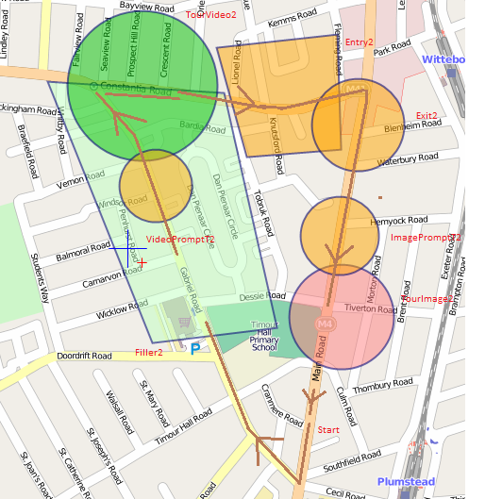

Tour2 - Drive 1 Test Sheet

Directions

* Start at office – go South on Mian road
* Right into Gabriel
* Right into Constantia
* Right into Main
* Go South
* Stop at office

Date and Time of Test : ………………………..

|  |  |  |  |  |  |
| --- | --- | --- | --- | --- | --- |
| Step | Where | Result Expected | Result | Rule 1 | Rule 2 |
| 1 | Start | Nothing |  | Always |  |
| 2 | Gabriel + 50m | Filler2.mp3 Starts |  | While | Priority 3 |
| 3 | Gabriel and Windsor intersection | Filler2 interrupted  VideoPrompt.mp3 plays |  | Entry | Priority 2 |
| 4 | Gabriel and Vernon road intersection | Tour video Icon becomes active on screen |  | Entry | Type V |
| 5 | Around Gabriel and Contantia road intersection | If Icon pressed TourVideo2.mp4 plays |  | ? |  |
| 6 | Around Gabriel and Contantia road intersection | Filler2.mp3 continues playing when Video ends |  | While | Priority 3 |
| 7 | Constantia rd and Lionel road intersection | Entry2.mp3 plays |  | Entry |  |
| 8 | Main and Waterbury | Exit2.mp3 plays |  | Exit |  |
| 9 | Main and Hemyock | ImagePromptT2.mp3 plays |  | Entry |  |
| 10 | 20 m before Main and Tiveton | Tour Image Icon becomes active on screen |  | Entry | Type I |
| 11 | Main and Tiveton | If Icon pressed TourImage2.jpg image shows |  | ? |  |